**A  
PROJECT REPORT  
ON**

**AMMUNITION WEBSITE  
USING HTML & CSS**

Submitted in partial fulfillment of the requirement  
for the award of the BCA Vth Semester  
  
**MAA SHAKUMBHARI UNIVERSITY**

**SAHARNPUR**

jsjsj



**Submitted By:-**

**Name:- AVNISH KUMAR**

**Roll No. :- 210954106022**

**D.A.V.(P.G.) COLLEGE,**

MUZAFFARNAGAR 251001

**“CERTIFICATE”**

It is certify that **AVNISH KUMAR s/o SUBODH KUMAR**student of **BCA-5TH of D.A.V(P.G) COLLEGE MUZAFFARNAGAR** has completed the project file on “Minor Project” under the guidance of **MRS.VISHALNI.**

This Project File is a part of course curriculum

We found the practical file satisfactory and we wish her bright future for his/her career.

**Mrs. Vishalni**

**DECLARATION**

We hereby declare that the project work entitled **“ AMMUNITION WEBSITE”** submitted to the DAV College Muzaffarnagar is a record of an original work done by **AVNISH KUMAR** under the guidance of **Mrs. Vishalni** this project work is submitted in the partial fulfilment of the requirements for the award of the Bachelor of Computer Application.

AVNISH KUMAR

**ACKNOWLEDGEMENT**

We would like to express our greatest appreciation to the all individuals who have helped and supported us throughout the project. We are thankful to our computer teacher for his ongoing support during the project, from initial advice, and encouragement, which led to the final report of this project on “AMMUNITION WEBSITE”.

A special acknowledgement goes to our classmates who helped us in completing the project by exchanging interesting ideas and sharing their experience.

We wish to thank our parents as well for their undivided support and interest who inspired us and encouraged us to go our own way, without whom We would be unable to complete our project.

At the end, we would like to thank our friends who displayed appreciation to our work and motivated us to continue our work.

AVNISH KUMAR

**CONTENTS**

* Front Page
* Declaration
* Acknowledgement
* Contents
* Preface
* Introduction About the Project
* Hardware & Software Requirement
* Relationship Between Webpages
* Introduction To Html & Css
* Source Code
* Snapshots (From Design)
* Conclusion & Future Scope
* Bibliography

**PREFACE**

We herby declare that the work which is being presented in the project entitled **“AMMUNITION WEBSITE”** is an authentic work carried out by us under guidance of **Mrs.Vishalni** of **D.A.V.(P.G.) College Muzaffarnagar.**

This project will work as reference to use the software**“AMMUNITION WEBSITE”.**

We had tried our best to keep it error free still. Perfection cannot be claim by humans.

**AVNISH KUMAR**

INTRODUCTION ABOUT  
 THE PROJECT

**AMMUNITION WEBSITE:**

"Ammunition Website aims to be the premier online destination for firearm enthusiasts and professionals alike. Offering a vast array of high-quality ammunition, firearms, and accessories, we cater to the needs of shooting sports enthusiasts, hunters, law enforcement, and military personnel. Our platform provides a user-friendly interface for easy browsing and purchasing, coupled with detailed product information to aid informed decision-making. With a commitment to excellence in both product quality and customer service, Ammunition Website strives to be the go-to resource for all firearm-related needs, ensuring a safe and enjoyable shooting experience for our valued customers."

**MAIN OBJECTIVE OF THIS PROJECT:**

The main objective of the Ammunition Website project is to provide a comprehensive online platform catering to the needs of firearm enthusiasts, professionals, and anyone interested in purchasing ammunition, firearms, and related accessories. The website aims to:

1. Offer a wide selection of high-quality ammunition, firearms, and accessories to meet the diverse needs of customers.

2. Provide a user-friendly interface for seamless browsing, product selection, and purchasing.

3. Ensure a safe and enjoyable shopping experience by adhering to all relevant regulations and safety guidelines.

4. Deliver detailed product information to facilitate informed decision-making by customers.

5. Establish a reputation for excellence in product quality, customer service, and reliability.

6. Serve as a trusted resource for shooting sports enthusiasts, hunters, law enforcement personnel, and military professionals.

7. Continuously improve and expand the platform to better meet the evolving needs of the firearm community.

**NECESSITY OF USING THE WEBSITE:**

The Ammunition Website serves as a vital resource for firearm enthusiasts and professionals due to several compelling reasons:

1. Accessibility: The website offers a convenient platform for users to browse and purchase a wide range of ammunition, firearms, and accessories from the comfort of their homes or workplaces.

2. Variety: With a diverse selection of products, including various calibers, types of ammunition, and firearm models, the website caters to the needs of different shooting sports enthusiasts, hunters, law enforcement agencies, and military personnel.

3. Informational Resources: Detailed product descriptions, specifications, and customer reviews provide valuable information to help users make informed purchasing decisions, ensuring they select the right products for their needs.

4. Convenience: Online ordering and delivery services streamline the purchasing process, saving users time and effort compared to traditional brick-and-mortar stores.

5. Quality Assurance: The website prioritizes offering high-quality ammunition and firearms, backed by reputable manufacturers and industry standards, enhancing user confidence in the products they purchase.

6. Customer Support: Responsive customer service channels and support features are available to address any inquiries, concerns, or issues promptly, ensuring a positive shopping experience for users.

In summary, the Ammunition Website serves as an indispensable platform for individuals and organizations seeking reliable, convenient, and quality firearm-related products and services.

**SOFTWARE & HARDWARE  
REQUIREMENTS**

* **Hardware Requirements:**

Processor : Pentium 4 or above

Memory : 2 GB RAM or above Hard disk : 20 MB or above

Keyboard : 108 keys

Monitor: SVGA Color

Mouse:PS/2, USB

* **Software Requirements:**

Operating System: Any Windows /Mac

Connection: TCP/IP

Programming Language: Html & Css

Frameworks : Bootstrap

Sources : Google Fonts, Unsplash,icons8

Protocol:HTTP,SMTP,POP3,WAP

**Relationship Between**

**Webpages**

Webpages can have various relationships depending on how they are interconnected. Common relationships between webpages include:

**Hyperlinks:** Webpages often link to each other through hyperlinks, creating a network of interconnected content on the web.

**Hierarchy:** Some webpages are organized hierarchically, with parent pages linking to child pages, creating a structured relationship.

**Navigation:** Webpages within the same website often have navigational links that allow users to move between them easily, establishing a navigational relationship.

**Related Content:** Websites may have sections or pages dedicated to related content, such as a blog post linking to related articles, establishing thematic relationships.

**References:** Academic or informational websites may cite or reference other webpages, establishing a scholarly relationship.

**Social Connections:** Webpages may be connected through social media platforms, where users share and interact with content, creating social relationships between webpages.

**Design and Layout:** Consistent design elements and layout across web pages can reinforce their relationship within a website and help users understand where they are in the site's structure.

Understanding these relationships is essential for creating a cohesive and user-friendly website navigation experience.

Overall, the relationship between webpages is dynamic and multifaceted, influenced by factors such as content, context, and user interaction.

**INTRODUCTION TO HTML  
& CSS**

## What is HTML?

HTML is the standard markup language for creating Web pages.

* HTML stands for Hyper Text Markup Language
* HTML describes the structure of Web pages using markup
* HTML elements are the building blocks of HTML pages
* HTML elements are represented by tags
* HTML tags label pieces of content such as "heading", "paragraph", "table", and so on
* Browsers do not display the HTML tags, but use them to render the content of the page

HTML is a computer language devised to allow website creation. These websites can then be viewed by anyone else connected to the Internet. It is relatively **easy to learn**, with the basics being accessible to most people in one sitting; and quite **powerful** in what it allows you to create. It is constantly undergoing revision and evolution to meet the demands and requirements of the growing Internet audience under the direction of the [**» W3C**](http://www.w3.org/), the organisation charged with designing and maintaining the language.

The definition of HTML is **HyperText Markup Language**.

* *HyperText* is the method by which you move around on the web — by clicking on special text called **hyperlinks** which bring you to the next page. The fact that it is*hyper* just means it is not linear — i.e. you can go to any place on the Internet whenever you want by clicking on links — there is no set order to do things in.
* *Markup* is what **HTML tags** do to the text inside them. They mark it as a certain type of text (*italicised* text, for example).
* HTML is a *Language*, as it has code-words and syntax like any other language.How does it work?
* HTML consists of a series of short **codes** typed into a text-file by the site author — these are the tags. The text is then **saved as a html file**, and **viewed through a** [browser](http://www.yourhtmlsource.com/starthere/glossary.html#browser), like Internet Explorer or Netscape Navigator. This browser reads the file and translates the text into a visible form, hopefully rendering the page as the author had intended. Writing your own HTML entails using tags correctly to create your vision. You can use anything from a rudimentary text-editor to a powerful graphical editor to create HTML pages.

**css:**

**Cascading Style Sheets**, fondly referred to as CSS, is a simple design language intended to simplify the process of making web pages presentable.

CSS handles the look and feel part of a web page. Using CSS, you can control the color of the text, the style of fonts, the spacing between paragraphs, how columns are sized and laid out, what background images or colors are used, layout designs,variations in display for different devices and screen sizes as well as a variety of other effects.

CSS is easy to learn and understand but it provides powerful control over the presentation of an HTML document. Most commonly, CSS is combined with the markup languages HTML or XHTML.

## Advantages of CSS

* **CSS saves time** − You can write CSS once and then reuse same sheet in multiple HTML pages. You can define a style for each HTML element and apply it to as many Web pages as you want.
* **Pages load faster** − If you are using CSS, you do not need to write HTML tag attributes every time. Just write one CSS rule of a tag and apply it to all the occurrences of that tag. So less code means faster download times.
* **Easy maintenance** − To make a global change, simply change the style, and all elements in all the web pages will be updated automatically.
* **Superior styles to HTML** − CSS has a much wider array of attributes than HTML, so you can give a far better look to your HTML page in comparison to HTML attributes.
* **Multiple Device Compatibility** − Style sheets allow content to be optimized for more than one type of device. By using the same HTML document, different versions of a website can be presented for handheld devices such as PDAs and cell phones or for printing.
* **Global web standards** − Now HTML attributes are being deprecated and it is being recommended to use CSS. So its a good idea to start using CSS in all the HTML pages to make them compatible to future browsers.
* **Offline Browsing** − CSS can store web applications locally with the help of an offline catche.Using of this, we can view offline websites.The cache also ensures faster loading and better overall performance of the website.
* **Platform Independence** − The Script offer consistent platform independence and can support latest browsers as well.

## Who Creates and Maintains CSS?

CSS was invited by **Håkon Wium Lie** on October 10, 1994 and maintained through a group of people within the W3C called the CSS Working Group. The CSS Working Group creates documents called **specifications**. When a specification has been discussed and officially ratified by W3C members, it becomes a recommendation.

These ratified specifications are called recommendations because the W3C has no control over the actual implementation of the language. Independent companies and organizations create that software.

**NOTE** − The World Wide Web Consortium, or W3C is a group that makes recommendations about how the Internet works and how it should evolve.

## CSS Versions

Cascading Style Sheets, level 1 (CSS1) was came out of W3C as a recommendation in December 1996. This version describes the CSS language as well as a simple visual formatting model for all the HTML tags.

CSS2 was became a W3C recommendation in May 1998 and builds on CSS1. This version adds support for media-specific style sheets e.g. printers and aural devices, downloadable fonts, element positioning and tables.

CSS3 was became a W3C recommendation in June 1999 and builds on older versions CSS. it has divided into documentations is called as Modules and here each module having new extension features defined in CSS2.

**SOURCE CODE**

**Html:**

<!doctype html>

<html lang="en">

<head>

<meta charset="utf-8">

<meta name="viewport" content="width=device-width, initial-scale=1">

<title>Bootstrap Project</title>

<link href="https://cdn.jsdelivr.net/npm/bootstrap@5.3.2/dist/css/bootstrap.min.css" rel="stylesheet"

integrity="sha384-T3c6CoIi6uLrA9TneNEoa7RxnatzjcDSCmG1MXxSR1GAsXEV/Dwwykc2MPK8M2HN" crossorigin="anonymous">

<style>

.btn a{

text-decoration:none;

color:white;

}

</style>

</head>

<body>

<!-- navbar -->

<nav class="navbar navbar-expand-lg navbar-dark bg-dark ">

<div class="container-fluid">

<a class="navbar-brand" href="#">i-Coder</a>

<button class="navbar-toggler" type="button" data-bs-toggle="collapse" data-bs-target="#navbarScroll"

aria-controls="navbarScroll" aria-expanded="false" aria-label="Toggle navigation">

<span class="navbar-toggler-icon"></span>

</button>

<div class="collapse navbar-collapse" id="navbarScroll">

<ul class="navbar-nav me-auto my-2 my-lg-0 navbar-nav-scroll" style="--bs-scroll-height: 100px;">

<li class="nav-item">

<a class="nav-link active" aria-current="page" href="#">Home</a>

</li>

<li class="nav-item ">

<a class="nav-link " href="/about.html">About</a>

</li>

<li class="nav-item dropdown">

<a class="nav-link dropdown-toggle" href="/" role="button" data-bs-toggle="dropdown"

aria-expanded="false">

Services

</a>

<ul class="dropdown-menu">

<li><a class="dropdown-item" href="https://en.wikipedia.org/wiki/Gun">Guns</a></li>

<li><a class="dropdown-item" href="https://en.wikipedia.org/wiki/Grenades">Grenades</a></li>

<li>

<hr class="dropdown-divider">

</li>

<li><a class="dropdown-item" href="https://en.wikipedia.org/wiki/Fighter Jets">Fighter

Jets</a></li>

<li><a class="dropdown-item" href="https://en.wikipedia.org/wiki/Tanks">Tanks</a></li>

<li><a class="dropdown-item" href="https://en.wikipedia.org/wiki/Submarine">Submarine</a>

</li>

</ul>

</li>

<li class="nav-item">

<a class="nav-link" href="/contact.html">Contact Us</a>

</li>

</ul>

<form class="d-flex" role="search">

<input class="form-control me-2" type="search" placeholder="Search" aria-label="Search">

<button class="btn btn-outline-danger" type="submit">Search</button>

</form>

<div class="mx-2">

<button class="btn btn-danger" data-bs-toggle="modal" data-bs-target="#loginModal">Login</button>

<button class="btn btn-danger" data-bs-toggle="modal" data-bs-target="#signupModal">SignUp</button>

</div>

</div>

</div>

</nav>

<!-- login-modal -->

<!-- Button trigger modal -->

<!-- <button type="button" class="btn btn-primary" data-bs-toggle="modal" data-bs-target="#loginModal">

Launch demo modal

</button> -->

<!-- Modal -->

<div class="modal-dialog modal-dialog-centered">

<div class="modal fade" id="loginModal" tabindex="-1" aria-labelledby="loginModalLabel" aria-hidden="true">

<div class="modal-dialog">

<div class="modal-content">

<div class="modal-header">

<h1 class="modal-title fs-5" id="loginModalLabel">Login</h1>

<button type="button" class="btn-close" data-bs-dismiss="modal" aria-label="Close"></button>

</div>

<div class="modal-body">

<form>

<div class="mb-3">

<label for="exampleInputEmail1" class="form-label">Email address</label>

<input type="email" class="form-control" id="exampleInputEmail1"

aria-describedby="emailHelp">

<div id="emailHelp" class="form-text">We'll never share your email with anyone else.

</div>

</div>

<div class="mb-3">

<label for="exampleInputPassword1" class="form-label">Password</label>

<input type="password" class="form-control" id="exampleInputPassword1">

</div>

<div class="mb-3 form-check">

<input type="checkbox" class="form-check-input" id="exampleCheck1">

<label class="form-check-label" for="exampleCheck1">Check me out</label>

</div>

<button type="submit" class="btn btn-primary">Login</button>

</form>

</div>

<div class="modal-footer">

<button type="button" class="btn btn-secondary" data-bs-dismiss="modal">Close</button>

<button type="button" class="btn btn-primary">Save changes</button>

</div>

</div>

</div>

</div>

</div>

<!-- sign-up modal -->

<div class="modal-dialog modal-dialog-centered">

<div class="modal fade" id="signupModal" tabindex="-1" aria-labelledby="signupModalLabel" aria-hidden="true">

<div class="modal-dialog">

<div class="modal-content">

<div class="modal-header">

<h1 class="modal-title fs-5" id="signupModalLabel">Create an i-Coder account</h1>

<button type="button" class="btn-close" data-bs-dismiss="modal" aria-label="Close"></button>

</div>

<div class="modal-body">

<form>

<div class="mb-3">

<label for="exampleInputEmail1" class="form-label">Email address</label>

<input type="email" class="form-control" id="exampleInputEmail1"

aria-describedby="emailHelp">

<div id="emailHelp" class="form-text">We'll never share your email with anyone else.

</div>

</div>

<div class="mb-3">

<label for="exampleInputPassword1" class="form-label">Password</label>

<input type="password" class="form-control" id="exampleInputPassword1">

</div>

<div class="mb-3">

<label for="cexampleInputPassword1" class="form-label">Confirm Password</label>

<input type="password" class="form-control" id="cexampleInputPassword1">

</div>

<div class="mb-3 form-check">

<input type="checkbox" class="form-check-input" id="exampleCheck1">

<label class="form-check-label" for="exampleCheck1">Check me out</label>

</div>

<button type="submit" class="btn btn-primary">Login</button>

</form>

</div>

<div class="modal-footer">

<button type="button" class="btn btn-secondary" data-bs-dismiss="modal">Close</button>

<button type="button" class="btn btn-primary">Save changes</button>

</div>

</div>

</div>

</div>

</div>

<!-- carousel -->

<div id="carouselExampleCaptions" class="carousel slide">

<div class="carousel-indicators">

<button type="button" data-bs-target="#carouselExampleCaptions" data-bs-slide-to="0" class="active"

aria-current="true" aria-label="Slide 1"></button>

<button type="button" data-bs-target="#carouselExampleCaptions" data-bs-slide-to="1"

aria-label="Slide 2"></button>

<button type="button" data-bs-target="#carouselExampleCaptions" data-bs-slide-to="2"

aria-label="Slide 3"></button>

</div>

<div class="carousel-inner">

<div class="carousel-item active">

<!-- <img src="" class="d-block w-100" > -->

<video class="d-block w-100" src="video1.mp4 "loop autoplay muted></video>

<div class="carousel-caption d-none d-md-block">

<h2>First slide label</h2>

<p>Ak-47 Animation</p>

<button class="btn btn-primary"><a href="https://en.wikipedia.org/wiki/AK-47">Ak-47</a></button>

</div>

</div>

<div class="carousel-item">

<video class="d-block w-100" src="video2.mp4" autoplay loop muted></video>

<div class="carousel-caption d-none d-md-block">

<h2>Second slide label</h2>

<p>Sukhoi SU-57</p>

<button class="btn btn-success"><a href="https://en.wikipedia.org/wiki/Sukhoi_Su-57">Aircraft</a></button>

</div>

</div>

<div class="carousel-item">

<video class="d-block w-100" src="kar98k.mp4" autoplay loop muted></video>

<div class="carousel-caption d-none d-md-block">

<h2>Third slide label</h2>

<p>Kar98k Sniper Rifle</p>

<button class="btn btn-danger" url="https://en.wikipedia.org/wiki/Kar98k">Kar98k</button>

</div>

</div>

</div>

<button class="carousel-control-prev" type="button" data-bs-target="#carouselExampleCaptions"

data-bs-slide="prev">

<span class="carousel-control-prev-icon" aria-hidden="true"></span>

<span class="visually-hidden">Previous</span>

</button>

<button class="carousel-control-next" type="button" data-bs-target="#carouselExampleCaptions"

data-bs-slide="next">

<span class="carousel-control-next-icon" aria-hidden="true"></span>

<span class="visually-hidden">Next</span>

</button>

</div>

<div class="container my-4">

<div class="row mb-2">

<div class="col-md-6">

<div

class="row g-0 border rounded overflow-hidden flex-md-row mb-4 shadow-sm h-md-250 position-relative">

<div class="col p-4 d-flex flex-column position-static">

<strong class="d-inline-block mb-2 text-primary-emphasis">Guns</strong>

<h3 class="mb-0">Featured post</h3>

<div class="mb-1 text-body-secondary">Nov 12</div>

<p class="card-text mb-auto">

Firearms are weapons that use explosive force to propel projectiles, often used for hunting,

self-defense, law enforcement, and military purposes.</p>

<a href="https://en.wikipedia.org/wiki/Gun"

class="icon-link gap-1 icon-link-hover stretched-link">

Continue reading

<svg class="bi">

<use xlink:href="#chevron-right"></use>

</svg>

</a>

</div>

<div class="col-auto d-none d-lg-block">

<img src="bexar-arms-9Fx3g0d6MDQ-unsplash.jpg" width="250" height="250" alt="">

</div>

</div>

</div>

<div class="col-md-6">

<div

class="row g-0 border rounded overflow-hidden flex-md-row mb-4 shadow-sm h-md-250 position-relative">

<div class="col p-4 d-flex flex-column position-static">

<strong class="d-inline-block mb-2 text-success-emphasis">Grenades</strong>

<h3 class="mb-0">Post title</h3>

<div class="mb-1 text-body-secondary">Nov 11</div>

<p class="mb-auto">Small handheld explosive devices, grenades are thrown to inflict damage or

create chaos in military operations or combat scenarios.</p>

<a href="https://en.wikipedia.org/wiki/Grenades"

class="icon-link gap-1 icon-link-hover stretched-link">

Continue reading

<svg class="bi">

<use xlink:href="#chevron-right"></use>

</svg>

</a>

</div>

<div class="col-auto d-none d-lg-block">

<img src="grenades.avif" width="250" height="250" alt="">

</div>

</div>

</div>

</div>

<div class="row mb-2">

<div class="col-md-6">

<div

class="row g-0 border rounded overflow-hidden flex-md-row mb-4 shadow-sm h-md-250 position-relative">

<div class="col p-4 d-flex flex-column position-static">

<strong class="d-inline-block mb-2 text-primary-emphasis">Fighter jets</strong>

<h3 class="mb-0">Featured post</h3>

<div class="mb-1 text-body-secondary">Nov 12</div>

<p class="card-text mb-auto">Fighter jets are military aircraft designed for air-to-air combat.

They establish air superiority, carry weapons like missiles and cannons, and can fly at

supersonic speeds.</p>

<a href="https://en.wikipedia.org/wiki/Fighter jets"

class="icon-link gap-1 icon-link-hover stretched-link">

Continue reading

<svg class="bi">

<use xlink:href="#chevron-right"></use>

</svg>

</a>

</div>

<div class="col-auto d-none d-lg-block">

<img src="tejas.jpg" width="250" height="250" alt="">

</div>

</div>

</div>

<div class="col-md-6">

<div

class="row g-0 border rounded overflow-hidden flex-md-row mb-4 shadow-sm h-md-250 position-relative">

<div class="col p-4 d-flex flex-column position-static">

<strong class="d-inline-block mb-2 text-success-emphasis">Design</strong>

<h3 class="mb-0">Post title</h3>

<div class="mb-1 text-body-secondary">Nov 11</div>

<p class="mb-auto">

Military tanks are heavily armored vehicles equipped with powerful weaponry, designed for

ground combat. They play a critical role in modern warfare, providing firepower, protection,

and mobility to armed forces..</p>

<a href="https://en.wikipedia.org/wiki/Tanks"

class="icon-link gap-1 icon-link-hover stretched-link">

Continue reading

<svg class="bi">

<use xlink:href="#chevron-right"></use>

</svg>

</a>

</div>

<div class="col-auto d-none d-lg-block">

<img src="tanks.jpg" width="250" height="250" alt="">

</div>

</div>

</div>

<div class="col-md-6">

<div

class="row g-0 border rounded overflow-hidden flex-md-row mb-4 shadow-sm h-md-250 position-relative">

<div class="col p-4 d-flex flex-column position-static">

<strong class="d-inline-block mb-2 text-success-emphasis">Submarine</strong>

<h3 class="mb-0">Post title</h3>

<div class="mb-1 text-body-secondary">Nov 11</div>

<p class="mb-auto">Watercraft capable of traveling underwater, used for military, research,

and exploration purposes, often equipped with advanced technology.</p>

<a href="https://en.wikipedia.org/wiki/submarine"

class="icon-link gap-1 icon-link-hover stretched-link">

Continue reading

<svg class="bi">

<use xlink:href="#chevron-right"></use>

</svg>

</a>

</div>

<div class="col-auto d-none d-lg-block">

<img src="submarine.jpg" width="250" height="250" my alt="">

</div>

</div>

</div>

<div class="col-md-6">

<div

class="row g-0 border rounded overflow-hidden flex-md-row mb-4 shadow-sm h-md-250 position-relative">

<div class="col p-4 d-flex flex-column position-static">

<strong class="d-inline-block mb-2 text-success-emphasis">Pistols</strong>

<h3 class="mb-0">Post title</h3>

<div class="mb-1 text-body-secondary">Nov 11</div>

<p class="mb-auto">Certainly! Pistols are handheld firearms characterized by a barrel with an

integral chamber. They come in various designs, including semi-automatic and revolver types.

</p>

<a href="https://en.wikipedia.org/wiki/submarine"

class="icon-link gap-1 icon-link-hover stretched-link">

Continue reading

<svg class="bi">

<use xlink:href="#chevron-right"></use>

</svg>

</a>

</div>

<div class="col-auto d-none d-lg-block">

<img src="pistols.avif" width="250" height="250" my alt="">

</div>

</div>

</div>

</div>

</div>

<hr class="featurette-divider">

<div class="container ">

<footer class="py-5 ">

<div class="row">

<div class="col-6 col-md-2 mb-3">

<h5>Section</h5>

<ul class="nav flex-column ">

<li class="nav-item mb-2"><a href="#" class="nav-link p-0 text-body-secondary">Home</a></li>

<li class="nav-item mb-2"><a href="#" class="nav-link p-0 text-body-secondary">Features</a></li>

<li class="nav-item mb-2"><a href="#" class="nav-link p-0 text-body-secondary">Pricing</a></li>

<li class="nav-item mb-2"><a href="#" class="nav-link p-0 text-body-secondary">FAQs</a></li>

<li class="nav-item mb-2"><a href="#" class="nav-link p-0 text-body-secondary">About</a></li>

</ul>

</div>

<div class="col-6 col-md-2 mb-3">

<h5>Section</h5>

<ul class="nav flex-column ">

<li class="nav-item mb-2"><a href="#" class="nav-link p-0 text-body-secondary">Home</a></li>

<li class="nav-item mb-2"><a href="#" class="nav-link p-0 text-body-secondary">Features</a></li>

<li class="nav-item mb-2"><a href="#" class="nav-link p-0 text-body-secondary">Pricing</a></li>

<li class="nav-item mb-2"><a href="#" class="nav-link p-0 text-body-secondary">FAQs</a></li>

<li class="nav-item mb-2"><a href="#" class="nav-link p-0 text-body-secondary">About</a></li>

</ul>

</div>

<div class="col-6 col-md-2 mb-3 ">

<h5>Section</h5>

<ul class="nav flex-column ">

<li class="nav-item mb-2"><a href="#" class="nav-link p-0 text-body-secondary">Home</a></li>

<li class="nav-item mb-2"><a href="#" class="nav-link p-0 text-body-secondary">Features</a></li>

<li class="nav-item mb-2"><a href="#" class="nav-link p-0 text-body-secondary">Pricing</a></li>

<li class="nav-item mb-2"><a href="#" class="nav-link p-0 text-body-secondary">FAQs</a></li>

<li class="nav-item mb-2"><a href="#" class="nav-link p-0 text-body-secondary">About</a></li>

</ul>

</div>

<div class="col-md-5 offset-md-1 mb-3">

<form>

<h5>Subscribe to our newsletter</h5>

<p>Monthly digest of what's new and exciting from us.</p>

<div class="d-flex flex-column flex-sm-row w-100 gap-2">

<label for="newsletter1" class="visually-hidden">Email address</label>

<input id="newsletter1" type="text" class="form-control" placeholder="Email address">

<button class="btn btn-primary" type="button">Subscribe</button>

</div>

</form>

</div>

</div>

<div class="d-flex flex-column flex-sm-row justify-content-between py-4 my-4 border-top">

<p>© 2024 i-Coder, Inc. All rights reserved.</p>

<ul class="list-unstyled d-flex">

<li class="ms-3"><a class="link-body-emphasis" href="#"><svg class="bi" width="24" height="24">

<use xlink:href="#twitter"></use>

</svg></a></li>

<li class="ms-3"><a class="link-body-emphasis" href="#"><svg class="bi" width="24" height="24">

<use xlink:href="#instagram"></use>

</svg></a></li>

<li class="ms-3"><a class="link-body-emphasis" href="#"><svg class="bi" width="24" height="24">

<use xlink:href="#facebook"></use>

</svg></a></li>

</ul>

</div>

</footer>

</div>

<script src="https://cdn.jsdelivr.net/npm/bootstrap@5.3.2/dist/js/bootstrap.bundle.min.js"

integrity="sha384-C6RzsynM9kWDrMNeT87bh95OGNyZPhcTNXj1NW7RuBCsyN/o0jlpcV8Qyq46cDfL"

crossorigin="anonymous"></script>

</body>

</html>

**OUTPUT SCREENSHOT (FROM DESIGN)**

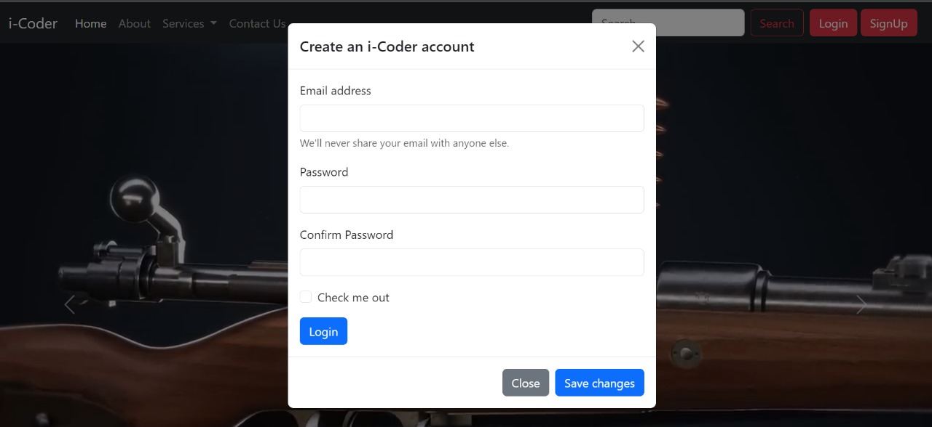

**About:**

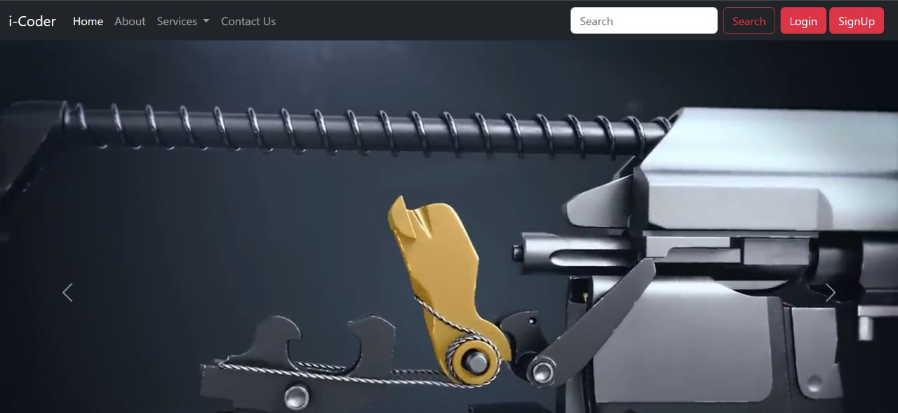

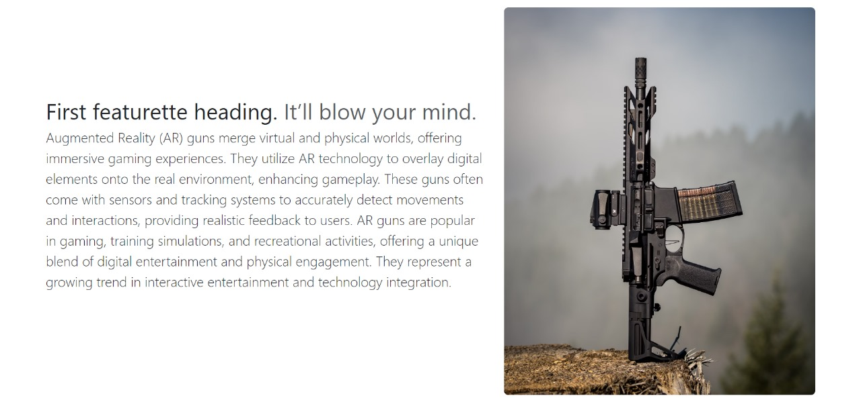

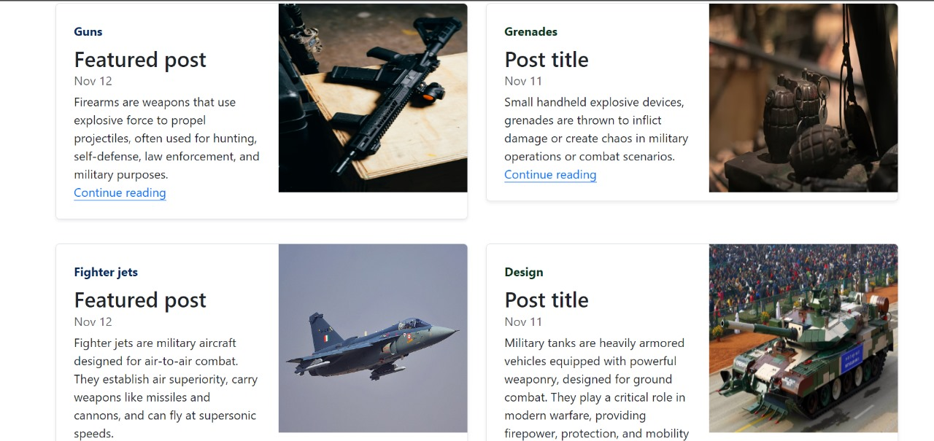

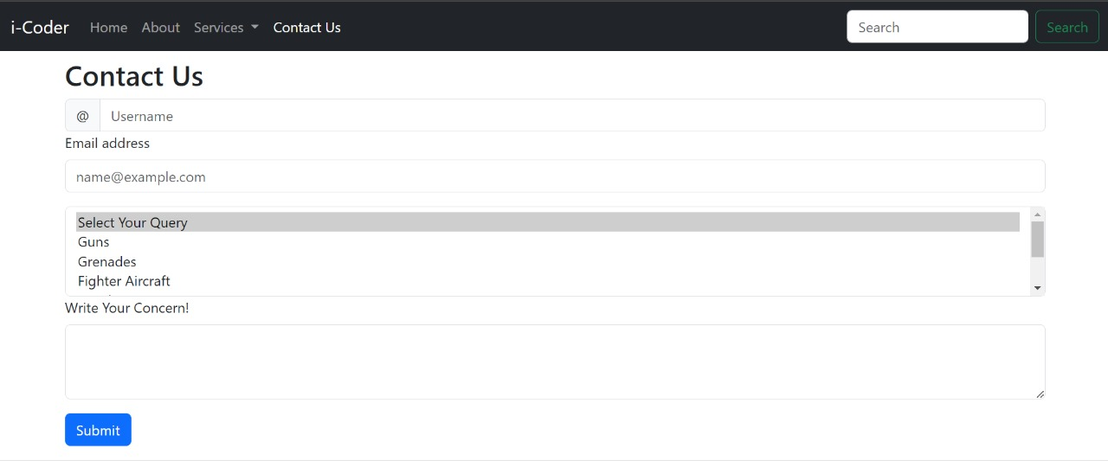

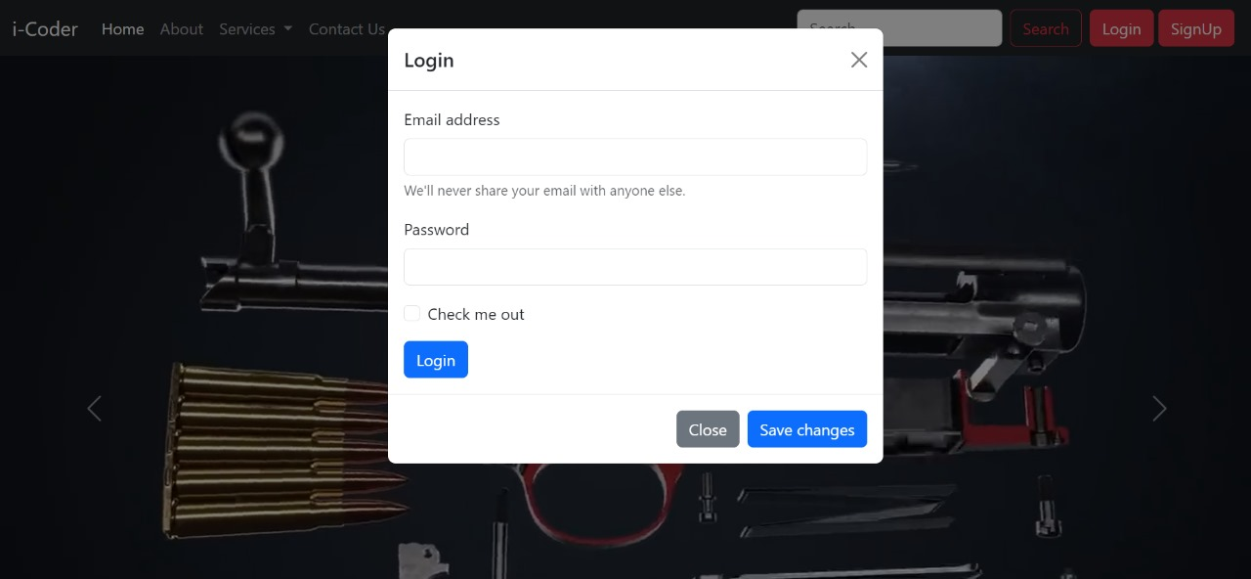

h

JGGG

**CONCLUSION**

In conclusion, the Ammunition Website stands as a paramount resource for firearm enthusiasts, professionals, and organizations alike. By offering a comprehensive selection of top-quality ammunition, firearms, and accessories coupled with user-friendly browsing and purchasing experiences, the website meets the diverse needs of shooting sports enthusiasts, hunters, law enforcement agencies, and military personnel. With an emphasis on accessibility, variety, information, convenience, quality assurance, and customer support, the Ammunition Website exemplifies excellence in the online firearms marketplace. It serves as a trusted destination where users can confidently acquire the necessary tools and equipment for safe and enjoyable shooting experiences.

**BIBLIOGRAPHY**

**BOOKS:**

* HTML and CSS: Design and Build Websites by Jon Duckett
* Learning Web Design: A Beginner's Guide to HTML, CSS, JavaScript, and Web Graphics" by Jennifer Niederst Robbins
* HTML5 Pocket Reference by Jennifer Niederst Robbins
* "HTML5 for Web Designers" by Jeremy Keith
* Head First HTML and CSS" by Elisabeth Robson and Eric Freeman
* CSS Secrets: Better Solutions to Everyday Web Design Problems" by Lea Verou
* CSS: The Missing Manual" by David Sawyer McFarland
* CSS Mastery: Advanced Web Standards Solutions" by Andy Budd, Cameron Moll, and Simon Collison
* Responsive Web Design with HTML5 and CSS3" by Ben Frain

**ONLINE REFERENCE:**

* [www.youtube.com](http://www.youtube.com/)
* [www.w3schools.com](http://www.w3schools.com/)
* [www.wilipedia.com](http://www.wilipedia.com/)
* [www.geeksforgeeks.com](http://www.geeksforgeeks.com/)
* [www.beginnersbook.com](http://www.beginnersbook.com)